**MongoDB Lab Assignments -Day 1**

**query the movies collection to**

1. **get all documents**

1. **get all documents with writer set to "Quentin Tarantino"**

1. **get all documents where actors include "Brad Pitt"**

1. **get all documents with franchise set to "The Hobbit"**

1. **get all movies released in the 90s**

1. **get all movies released before the year 2000 or after 2010**

**Update Documents**

1. **add a synopsis to "The Hobbit: An Unexpected Journey" : "A reluctant hobbit, Bilbo Baggins, sets out to the Lonely Mountain with a spirited group of dwarves to reclaim their mountain home - and the gold within it - from the dragon Smaug."**

1. **add a synopsis to "The Hobbit: The Desolation of Smaug" : "The dwarves, along with Bilbo Baggins and Gandalf the Grey, continue their quest to reclaim Erebor, their homeland, from Smaug. Bilbo Baggins is in possession of a mysterious and magical ring."**

1. **add an actor named "Samuel L. Jackson" to the movie "Pulp Fiction"**

**Text Search**

**1. find all movies that have a synopsis that contains the word "Bilbo"**

**2. find all movies that have a synopsis that contains the word "Gandalf"**

1. **find all movies that have a synopsis that contains the word "Bilbo" and not the word "Gandalf**"

1. **find all movies that have a synopsis that contains the word "dwarves" or "hobbit"**

1. **find all movies that have a synopsis that contains the word "gold" and "dragon"**

**Delete Documents**

**1. delete the movie "Pee Wee Herman's Big Adventure"**

**2. delete the movie "Avatar"**

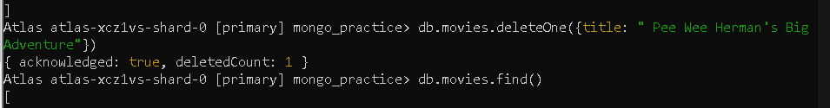



**Relationships**

1. **find all users**

1. **find all posts**

1. **find all posts that was authored by "GoodGuyGreg"**

1. **find all posts that was authored by "ScumbagSteve"**

1. **find all comments**

1. **find all comments that was authored by "GoodGuyGreg"**

1. **find all comments that was authored by "ScumbagSteve"**

1. **find all comments belonging to the post "Reports a bug in your code"**

